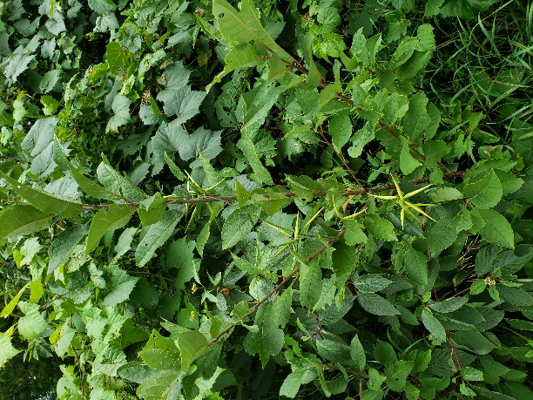

Figure : Example of vine growing in treed area.

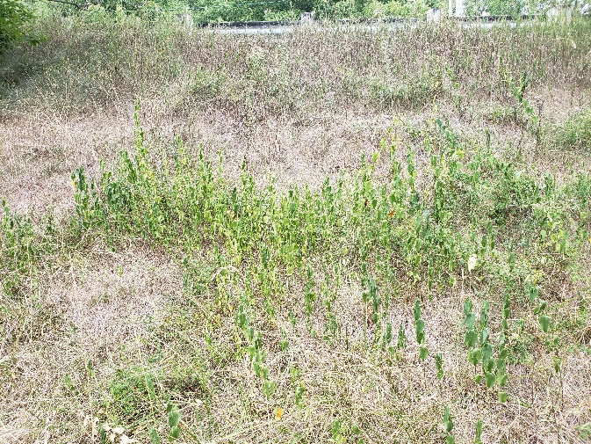

Figure : Example of vine growing on slope.