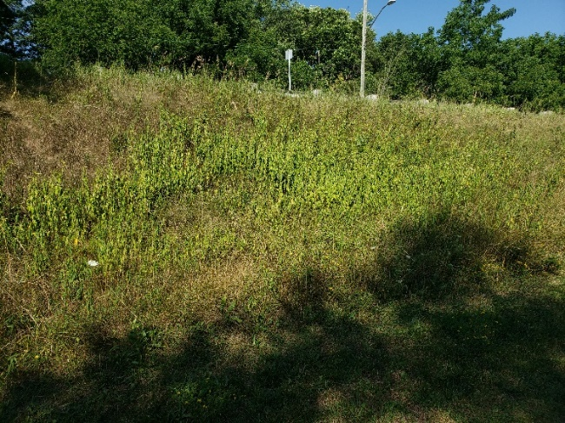

Figure : Dog strangling on east slope looking east

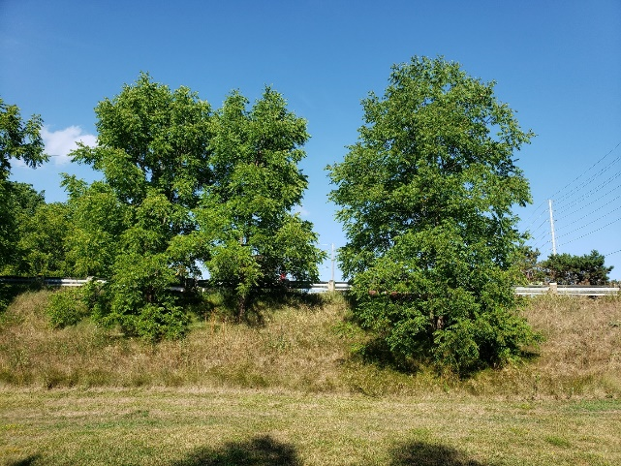

Figure : trees and grasses on east slope looking east

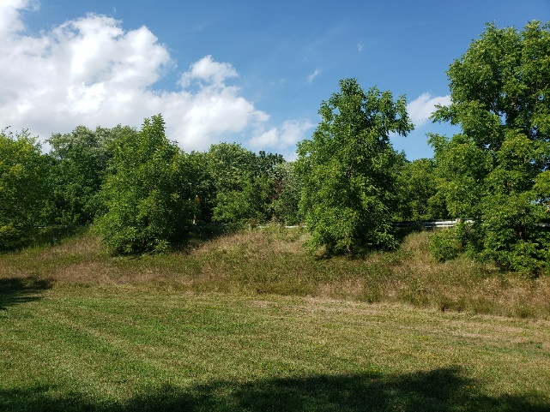

Figure : trees and grasses on eat slope looking north east

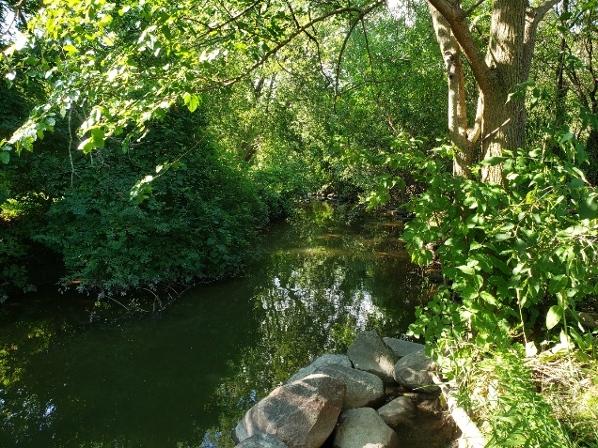

Figure : Harmony creek looking north

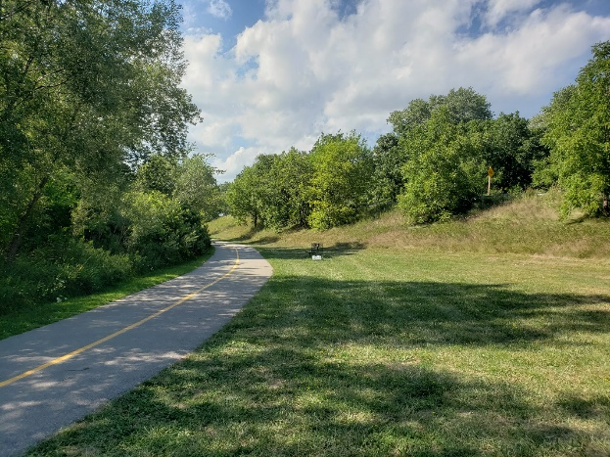

Figure : manicured grass east of trail looking north

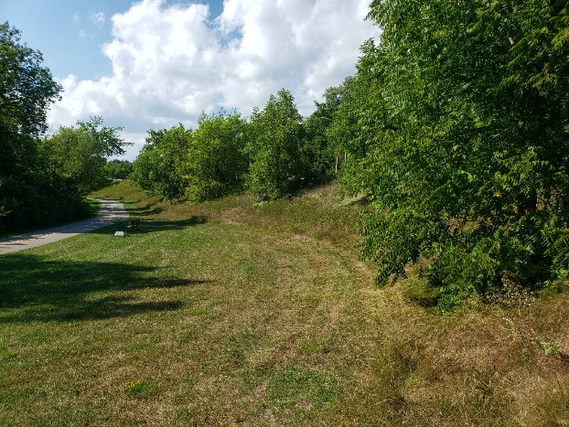

Figure : manicured grass looking north

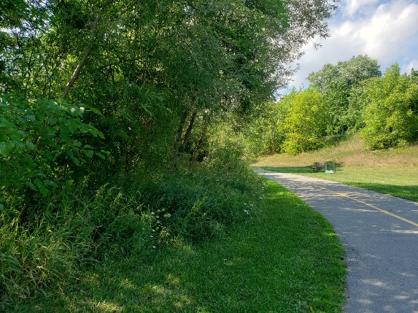

Figure : transition from bank vegetation to trail looking north

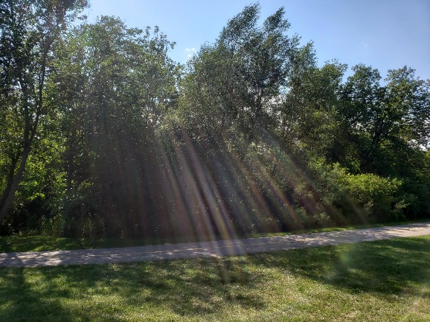

Figure : tree line along east bank of creek and trail looking west

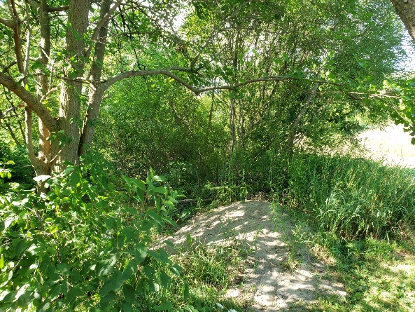

Figure : vegetated area between harmony creek and tail looking north.