The area I have chosen to observe is my backyard. The yard is separated into two section by a large trees. The section closest to the house has grass, with a trampoline, and pavement with trees on two sides. On the other side of the trees is an area that was unkept by the previous tenant and was overgrown with weeds that I have kept down since I moved in through consistent mowing and the use of herbicides so the area could be used later for planting flowers. The last time I sprayed herbicide was late July/ early August. I was out in my yar from six pm to seven pm on September 24th. It as sixteen degrees, sunny and very windy out. The wind was blowing at about 40 km/hour and gusting up to 60 km/hour. The season is fall.

Image one: Back part of the yard where herbicide had to be used:

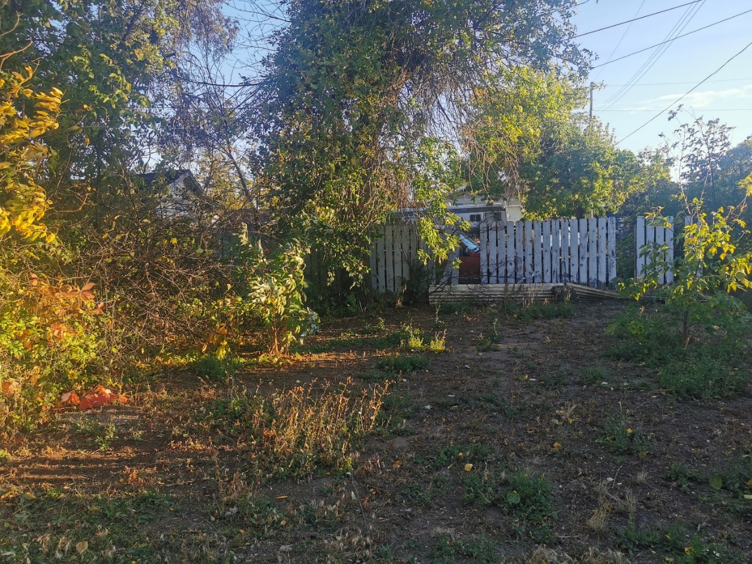

This weather is very typical of where I live this time of year. I usually have various types of birds in my yard, mainly magpies, sparrows and robins. It is not often I see both birds’ types at the same time. There are also many ants in the yard.

Image 2: Front part of the yard where no herbicide was used

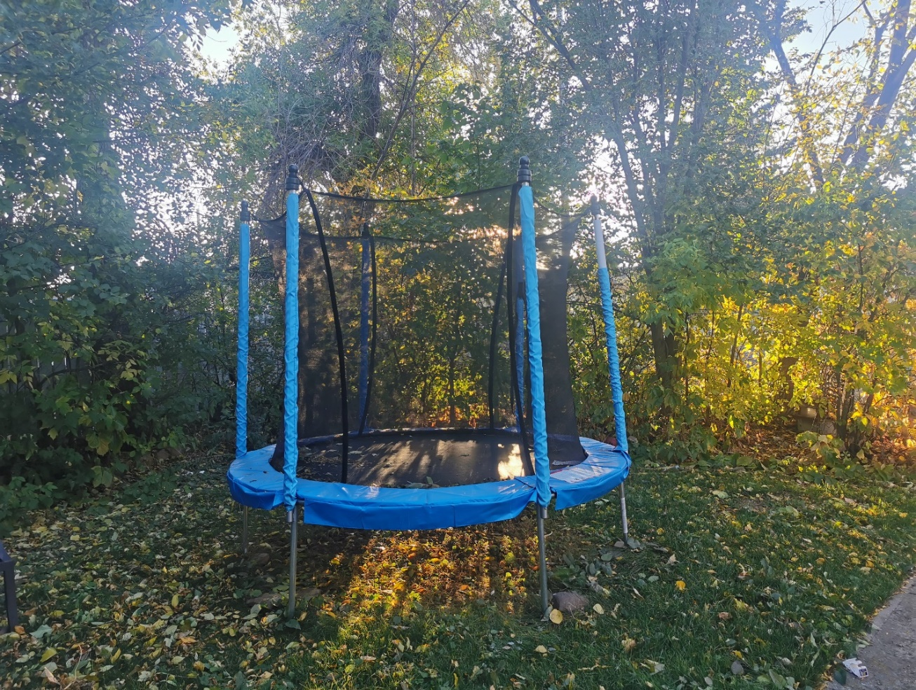

Image three: Field notes

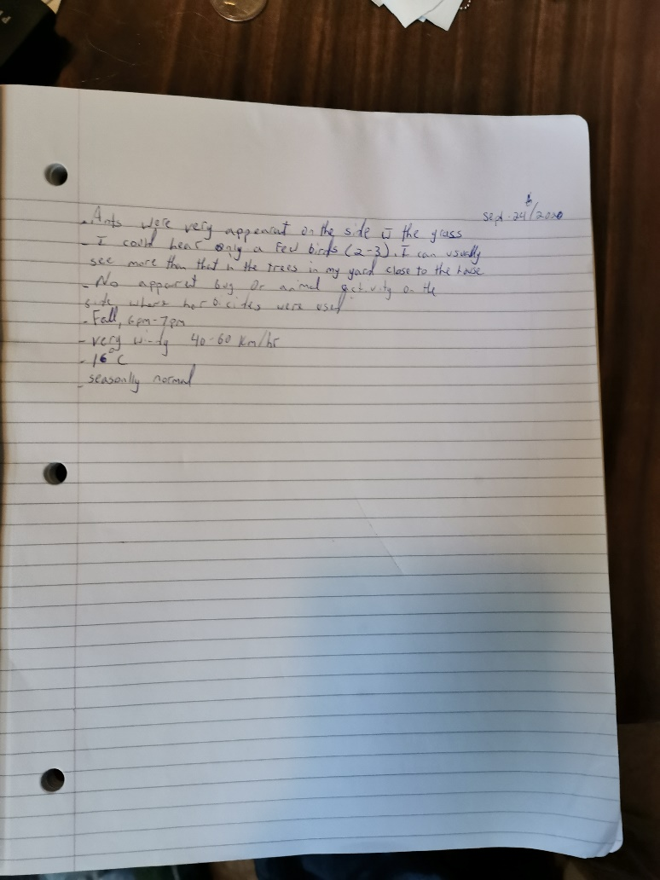

3 questions I have about the area:

1. How does wind affect bird presence?
2. How does the use of a herbicide effect animal location?
3. How does the type of birds effect if other birds come around the yard?