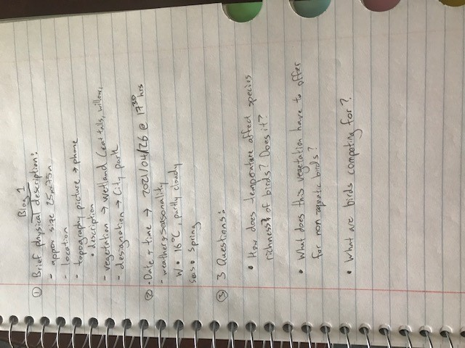

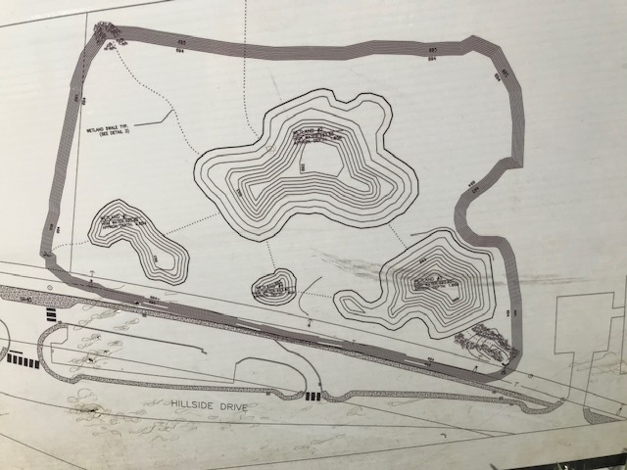

*Figure 2: Topographical Map Photo*

*Figure 1: Written Field Journal Entry*

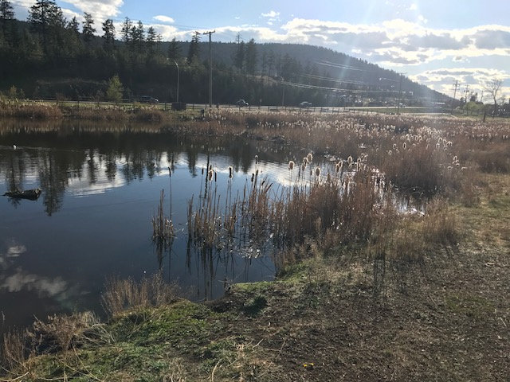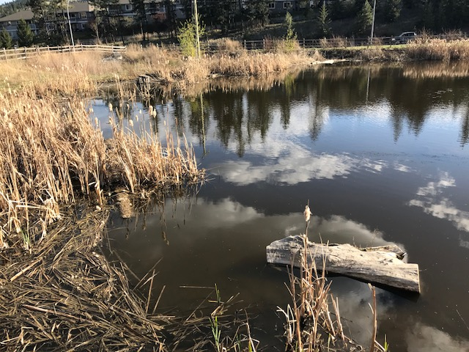

*Figure 3: Photos of Dufferin Park Wetland – Left Side*

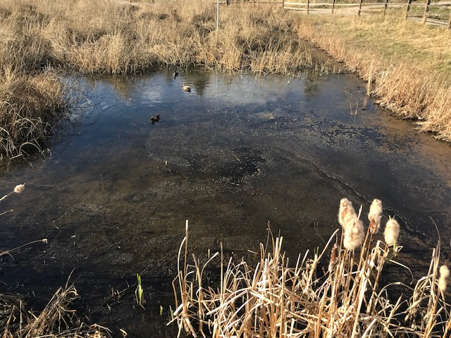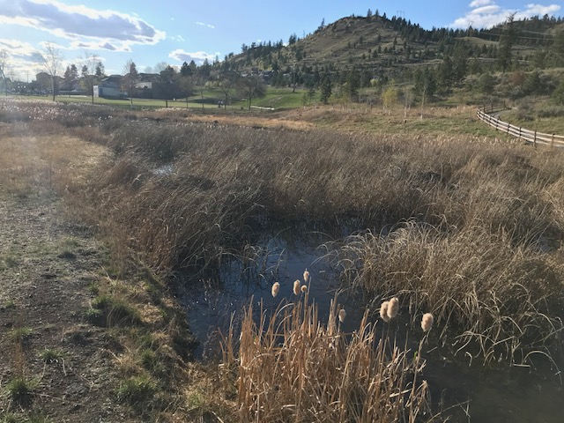

*Figure 4: Photos of Dufferin Park Wetland – Right Side*

- End of Journal Entry -