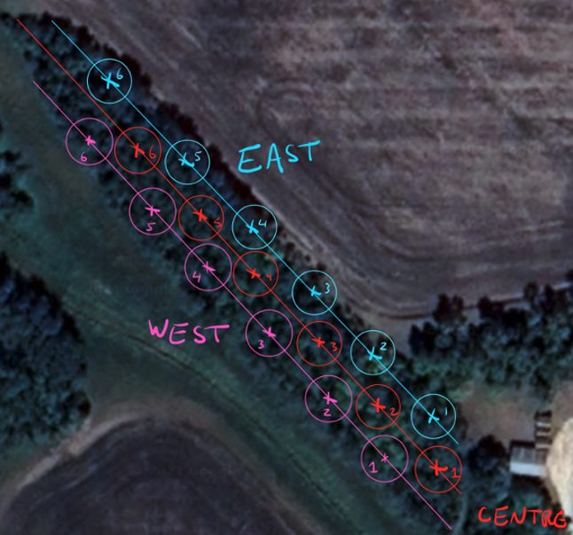

**Figure 1.** Schematic representation of sample locations. Samples were taken from circle plots with a 5m radius that were systematically selected to be non-overlapping between transects and approximately 20 paces from each other on each transect. Soil samples were extracted from the centre of each circle plot. All *P. alba* with a DBH ≥ 8cm that were within the circle plot were included in the measurements of tree density.